Power Electronics - Boost Converter

**Main vocabulary from power electronics**

* Ripples can, however, be eliminated/ reduced considerably with the help of filter circuit.( A combination of capacitor and inductor in the output circuit)..
  + 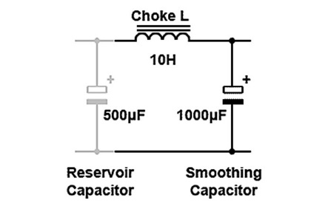Ripple voltage can be reduced by using capacitors or filters, but it cannot be eliminated entirely.

## Reducing ripple in power supplies

* The ripple can be reduced by smoothing capacitors which converts the ripple voltage into a smoother dc voltage. Aluminum electrolytic capacitors are widely used for this and have capacitances of 100uF or more
* Diode bootstrapping is used to protect the circuit from ripple current when switching the power
* The inductor is the principal component included in boost convert all schematic and diagram we can find the inductor
* inductor and Capacitor in Buck converter are used to
* A low pass filter maybe a good chose to reduce the ripple voltage more than a capacitor, as shown in Figure 9

## **Ripple and Noise Origin**

**Reducing EMI - diode back connection inductance**

The metal shell can be adopted as the shield which is used to reduce the radiated interference of the external electromagnetic field. In order to reduce the electromagnetic interference of the power line input, the power input terminal is equipped with the [EMI power line filter](https://www.ato.com/filters), just as the below diagram shows (the EMI filter is also named the power line filter). This is also a method usually used to restrain high-frequency noise.

## **Boost Converter**

Definition: Boost Converters sometimes, also known as step-up choppers are the type of chopper circuits that provides such an output voltage that is more than the supplied input voltage



## **Duty Cycle**

1. Walid Issa BOSST CONVERTER
2. Diagram, schematic

   Description automatically generatedA picture containing text, sky, bunch, screenshot

   Description automatically generated

* + - **Battery charger**

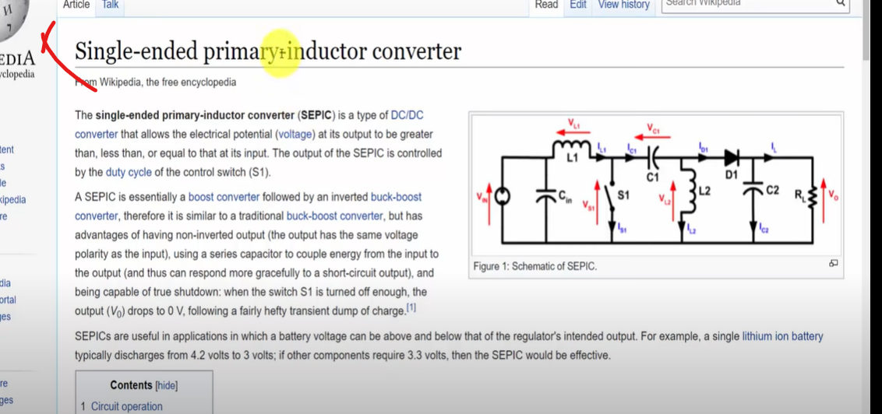Strap capacitor